Date: 11.04.2025
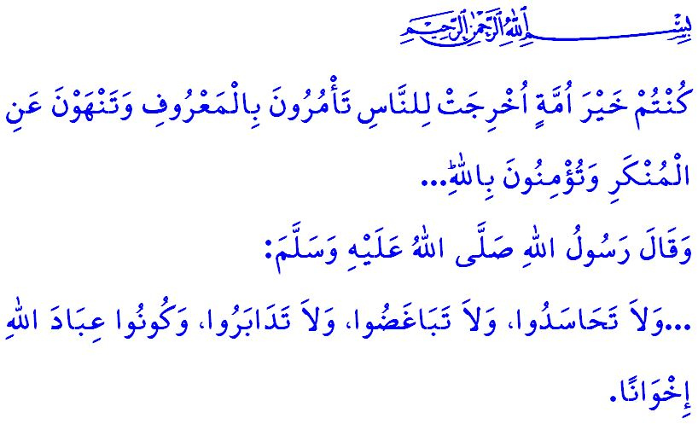
BEING AN UMMAH IS BEING UNITED
Honorable Muslims!
Today, as in times past, the oppressors have not relinquished their ambitions to sow division within the Ummah of Muhammad and to occupy the lands of Islam. They employ every means to undermine the unity and solidarity of the Ummah, setting its members against one another and, moreover, making Muslims kill Muslims. These murderers, who recognize neither rights nor laws, burn people alive, young and old, men and women alike, on their own land, perpetrating a heinous genocide before the eyes of the entire international community. Each day, hundreds of innocent lives are lost, either beneath relentless bombardment or through the slow agony of starvation. The cries of children shake the very firmament; the wails of mothers echo through the heavens; and the helplessness of fathers pierces the hearts of all who possess compassion and conscience. The root cause of these sufferings is not the strength of the oppressors, but our own disunity as Muslims, disorganized, fragmented, unresponsive, and numb to one another’s pain. It is the fact that we forget that in unity lies mercy, and in division, wrath.
Dear Believers!
As in the words of our Prophet (saw), sadly, today we Muslims, despite our great numbers, are scattered like rubbish carried down by a torrent of water. Our enemies descend upon the lands of Islam like wild beasts upon their prey. The excessive love of this world and the fear of death are stripping away our dignity and grandeur in the eyes of our enemies. Despite the command of our Almighty Lord, وَاعْتَصِمُوا بِحَبْلِ اللّٰهِ جَم۪يعاً وَلَا تَفَرَّقُواۖ “Hold firmly together to the rope of Allah and do not be divided...”, we find ourselves drifting further apart each day, driven by worldly interests and personal ambitions. This situation only emboldens the oppressors, leading them to intensify their cruelty.
Dear Believers!
True peace can only prevail on earth again when the Ummah of Muhammad unites on the foundation of brotherhood, acting in unity and solidarity. It is through our coming to each other’s aid as required by the verse, وَالَّذ۪ينَ اِذَٓا اَصَابَهُمُ الْبَغْيُ هُمْ يَنْتَصِرُونَ “... who enforce justice when wronged.” This can only be achieved by binding together as closely as the bricks of a building and sharing in each other’s pain as the members of a body as required by the hadith, “…Do not envy one another. Do not bear grudges against one another. Do not turn your backs on one another. O servants of Allah, be brothers!” It is only possible for us through acting with the spirit of brotherhood as believers, transcending differences in language, color, race, sect, and profession, as required by the verse, اِنَّمَا الْمُؤْمِنُونَ اِخْوَةٌ “The believers are but one brotherhood.” It is only possible for through recognizing everyone who accepts Allah as their Lord, Islam as their religion, and Prophet Muhammad (saw) as their prophet as part of the Islamic family as required by the verse, اِنَّ هٰذِه۪ٓ اُمَّتُكُمْ اُمَّةً وَاحِدَةًۘ وَاَنَا۬ رَبُّكُمْ فَاعْبُدُونِ “Indeed, this religion of yours is ˹only˺ one, and I am your Lord, so worship Me ˹alone˺.”It is only possible for us through enjoining good and prevent evil as required by the verse, “You are the best community ever raised for humanity— you encourage good, forbid evil, and believe in Allah...”
Esteemed Muslims!
It is Islam that united the Emir of the Believers, Umar, with Salman al-Farisi, and Bilal al-Habashi, with Byzantine Suhayb, making them brothers. Preserving this brotherhood and passing it on to future generations is not a mere preference or option for us, but a religious duty and a moral responsibility. Let us, then, join hands and hearts as Muslims, united by belief in the same Allah, following the same prophet, guided by the same divine book, and facing the same qiblah. As our beloved nation and part of the broader Islamic world, let us strive to further strengthen our unity, solidarity, love, and brotherhood.
O humanity!

A nation is being utterly destroyed in Gaza. Hospitals, schools, and even places of worship have been destroyed. Not only Muslims, but also humanitarians delivering aid, healthcare workers striving to heal, and members of the press working to expose this persecution to the world are being massacred Oppression will ultimately come to an end. The oppressed will surely be delivered to salvation. The oppressors will never succeed in their goal. From this point, I call upon people of conscience and humanity to stand against a handful of murderous gangs and their accomplices, and to show their dignified response. Let us not forget that consenting to oppression is, in itself, a form of oppression.

Abu Dawud, Malahim, 5; Ibn Hanbal, V, 278.
Ali 'Imran, 3/103.
Shura, 42/39
Muslim, Birr, 28.
Hujurat, 49/10.
Anbiya, 21/92.
Ali 'Imran, 3/110. General Directorate of Religious Services

